Briefing Paper
To
Overview and Scrutiny (Corporate)
On
15 February 2022
SERVICE PLAN PERFORMANCE INDICATORS – THIRD QUARTER 2021/22

1. SUMMARY

  - As part of the Council’s Performance Management and Continuous Improvement Framework all service areas are required to develop an annual Service Plan which sets out the key activities to be delivered and the measures (performance Indicators) used to monitor the impact of those activities.

  - Enclosed is the report (Appendix 8 ) for Service Plan Performance Indicators for all service areas including:

- People and Transformation
- Neighbourhood Services
- Finance
- Law and Governance
- Planning and Regeneration
- Housing
- Health and Communities

  - Whilst there is a total of 159 indicators relating to the above Service Plans, 129 are reported on a quarterly basis and 34 indicators are reported on an annual basis.

  - For the quarterly indicators outside the tolerance level, Intervention Plans (where required) are produced detailing the strategies to be adopted to bring these indicators on target, 7 were required this quarter (see appendix 1-7)

Appendix 1: Intervention Plan - Average number of calendar days to
complete all repairs.
Appendix 2: Intervention Plan - Average re-let time (standard voids)
Appendix 3: Intervention Plan - % of rent lost through vacant dwellings
Appendix 4: Intervention Plan - Average days lost to sickness
Appendix 5: Intervention Plan - Percentage of Occupational Health referrals
seen within timescales.
Appendix 6: Intervention Plan – Sampled streets achieving grade A or B for
litter and detritus
Appendix 7: Intervention Plan – Complaints.

2. BACKGROUND

2.1 The current value column contained within the report refers to the quarterly
outturn figure for 2021/22.

2.2 The short term trend column shows the trend in outturn figures for 2021/22 compared to the previous quarter 2 outturn figures for 2021/22.

2.3. The traffic light icons denote whether the indicator has:

 Met or exceeds the target

 Not met the target but is within the tolerance level

 Not met the target and falls outside the tolerance level

2.4 Performance against target – of the 129 quarterly indicators, 47 are above, on or within 1% of the target set; 10 are within the tolerance level; 15 are under target and 57 indicators are for monitoring purposes only and have no target set.

2.5. Fig 1 below provides a summary of the status of all service plan indicators against the targets set

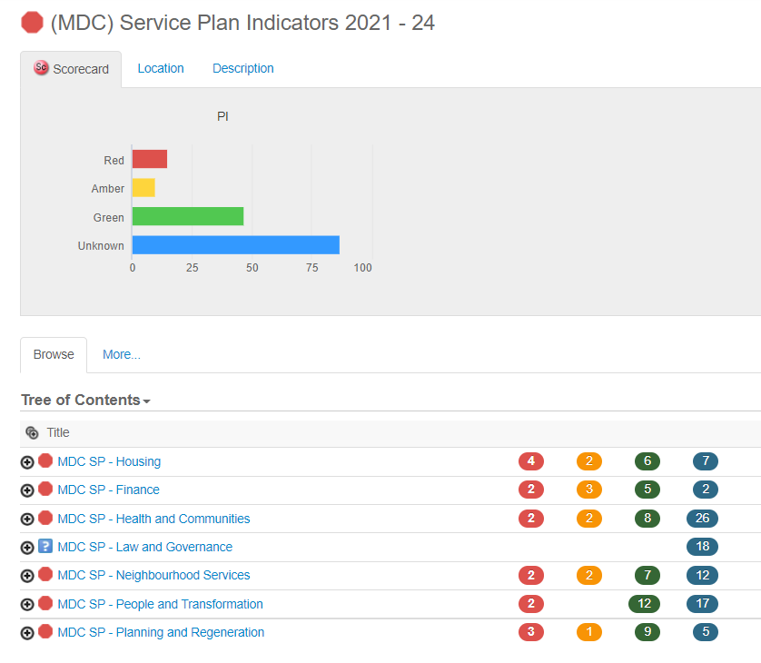

2.6. “Unknown” refers to those indicators that do not have a target set and are for monitoring purposes only, and annual performance indicators which will be reported on in Q4: 2021/22.

2.7. The graph (1) below shows a comparison of performance outturn for quarter 3 compared with quarter 1 and quarter 2 for 2021/22

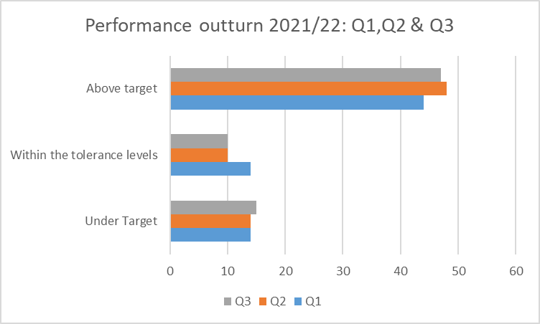

3. BUDGETARY/RESOURCE IMPLICATIONS

3.1 There are no budgetary / resource implications in the development of the performance management and reporting framework.

4. ALIGNMENT TO COUNCIL PRIORITIES

4.1 The performance management framework is aligned to the Council’s ambitions and priorities set out in Making Mansfield: Towards 2030.

Report Author | - | James Biddlestone
Designation | - | Head of People and Transformation
Telephone | - | 01623 463336
E-mail | - | jbiddlestone@mansfield.gov.uk

